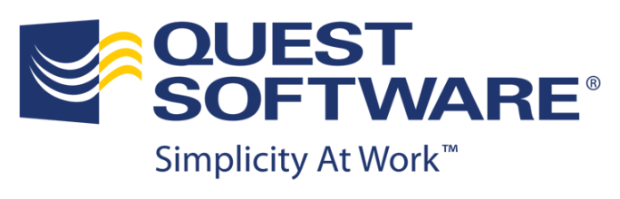
Editorial Contact:
Scott Desiere
949-754-8617 scott.desiere@quest.com
Twitter: @Quest_News

Media Alert
New Report Ranks Quest as One of Top 3 Vendors for Virtual Server Management Software
Aliso Viejo, Calif., July 25, 2011
News Facts:
Quest Software, Inc. (Nasdaq: QSFT) today announced that a new report by industry analyst firm IDC ranks it as one of the top three vendors by market share for virtual server management software, for the second consecutive year. The report specifically notes that, “Quest Software continues to build on the base established by the Vizioncore acquisition as well as extending the vFoglight business.”

- Titled, “Worldwide Distributed Virtual Server Management Software 2011-2015 Forecast and 2010 Vendor Shares” (Doc #228817), the IDC report provides a market size and vendor share analysis for the worldwide distributed virtual server management software market in 2010. Quest ranked third on the overall list, trailing only leading platform vendors VMware and Microsoft.

- IDC projects continued growth for the worldwide virtual server management software industry at large, estimating in the report that “the market will total $1.4 billion by 2015, representing a 5-year CAGR of 11.1 percent.”

Quest Virtual Server Management Solutions:

- With more than 38,000 customers worldwide, Quest® vRanger® is the first VMware backup and recovery solution to feature agentless VM backup, active block mapping for deleted data, Fibre SAN restore, and full integrated cataloging.

- Quest® vFoglight®, a leading performance monitoring and management tool for virtualized environments, provides administrators with the visibility they need to resolve VMware ESX and Hyper-V performance management issues.

Supporting Quotes:
Mary Johnston Turner, research vice president, IDC, Enterprise Systems Management
“As enterprise data centers and cloud service providers continue to deploy complex, virtualized infrastructure to support a wide range of production applications and services, sophisticated, automated management software will be required to efficiently monitor, control and optimize the performance of these environments. Our recent analysis shows that Quest continues to be a major player in this market.”

Carl Eberling, vice president and general manager, Virtualization and Monitoring, Quest Software

“The new report from IDC once again demonstrates Quest’s position as the market's leading independent software vendor for virtual server management solutions. As virtualization continues to mature as a mainstream IT practice with widespread global adoption, Quest remains committed to delivering software solutions that simplify processes, and assure optimal protection, performance and viability of virtual environments.”

About Quest Software, Inc.
Quest Software (Nasdaq: QSFT) simplifies and reduces the cost of managing IT for more than 100,000 customers worldwide. Our innovative solutions make solving the toughest IT management problems easier, enabling customers to save time and money across physical, virtual and cloud environments. For more information about Quest solutions for administration and automation, data protection, development and optimization, identity and access management, migration and consolidation, and performance monitoring, go to www.quest.com.

# # #
Quest, Quest Software, vFoglight and the Quest logo are trademarks or registered trademarks of Quest Software in the United States and certain other countries. vRanger is a trademark or registered trademark of Vizioncore Inc. in the United States and certain other countries. All other trademarks and registered trademarks are property of their respective owners.

RSS Feeds:
Quest news releases: www.quest.com/rss/news-releases.aspx

Web Links Referenced in this Release:
Quest Software, Inc.: http://www.quest.com/
VMware Backup and Recovery: http://www.quest.com/vranger
Performance Monitoring and Management: http://www.quest.com/vfoglight/
Administration and Automation: http://www.quest.com/administration-and-automation/
Data Protection: http://www.quest.com/data-protection/
Development and Optimization: http://www.quest.com/development-and-optimization/
Identity and Access Management: http://www.quest.com/identity-management/
Migration and Consolidation: http://www.quest.com/migration-and-consolidation/
Performance Monitoring: http://www.quest.com/performance-monitoring/
Twitter: http://twitter.com/#!/Quest
Facebook: www.quest.com/facebook
LinkedIn: www.quest.com/linkedin
YouTube: www.quest.com/youtube

